PHYS107-ON: Introductory Meteorology
Lab #11 (NJ Hourly Surface Observations, Analyzing Model Data, and Preparing a Forecast)

Use Canvas submit box for images and file download.
Use your PowerPoint and readings from the chapter materials to find the answers to the questions listed below. The video links in this lab module should be watched before completing the lab. You may also look up the answers using an outside resource or search engine. The student uploaded the entire lab document within the Canvas submit box. Student highlighted answers after the questions embedded in the document. The student submitted related images as instructed.
When asked to draw: take a picture, scan an image or use an electronic device to draw your sketch, then upload/embed the image into your document before submitting.
Part 1. (Q / A) Complete question 1 and then pick 5 of these (Q 2-9) to answer for full credit.
1: Please go to the following website (https://www.ncdc.noaa.gov/cdo-web/datatools/lcd).
Under "Select a Location Type", choose State. Select New Jersey.
Scroll down to where it says “STATION DETAILS"
Click on each station and/or View Full Details (on the left) for the Latitude and Longitude
coordinates, and use those coordinates to label each asterisk on the
Figure 1 (New Jersey County Map).
(Do not worry about Atlantic City Marina, NJ – skip them)
Then, on the New Jersey County map (Figure 1), label the
hourly surface weather observation stations by their 4-letter station identifier.
To find each station identifier, reference Table 1.
KEWR (Newark International Airport) has already been labelled as an example.
Scan or take a picture of the completed map and attach it to the lab document before submitting it.
The map below shows the weather observation stations by their four letters identifying them. There are a total of seventeen weather observation systems in New Jersey.
- K12N (Aeroflex Andover Airport)
- KACY (Atlantic City International Airport)
- KBLM (Belmar Farmingdale Allaire Airport)
- KCDW ( Caldwell Essex County Airport)
- KNEL (Lakehurst NAS)
- KLDJ (Linden Airport)
- KWRI (McGuire AFB)
- KMIV (Millville Municipal Airport)
- KMMU (Morristown Airport)
- KVAY (South Jersey Regional Airport)
- KEWR (Newark Liberty International Airport)
- KMJX (Ocean County Airport)
- KSMQ (Somerset Airport)
- KFWN (Sussex Airport)
- KTEB (Teterboro Airport)
- KTTN (Trenton Mercer Airport)
- KWWD (Wildwood Cape May County Airport)
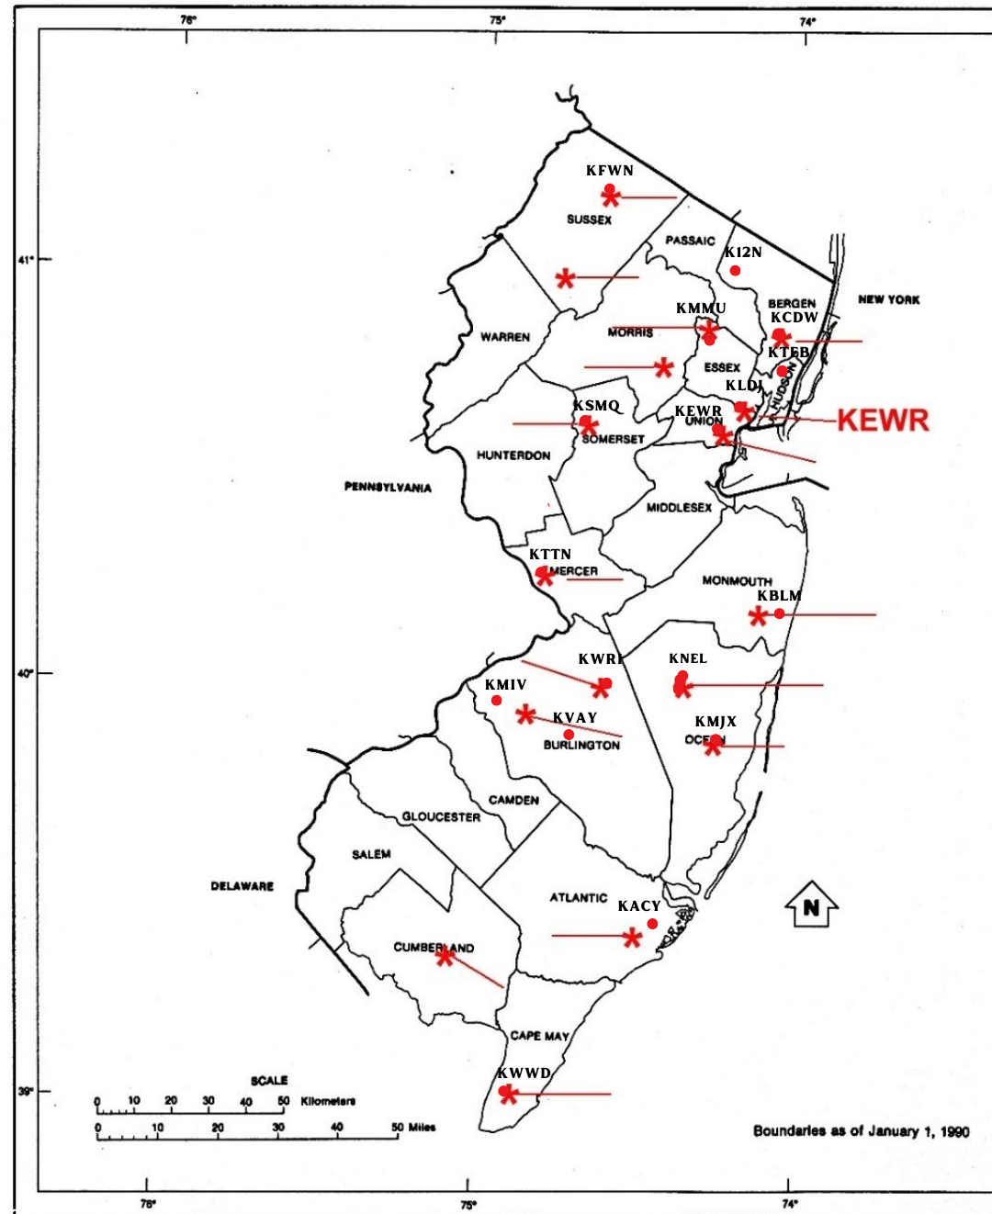

2: Name the hourly surface weather observation stations in Sussex County, NJ?
Answer- The hourly surface weather observation stations in Sussex County, NJ, are as follows:
- Zone Area Forecast for Sussex Business, run by the National Weather Service of the Government

- Sussex, NJ Hourly Weather Forecast, run by Weather Underground

- Sussex County, NJ weather forecast, run by local weather conditions

- Sussex, New Jersey (NJ) 07461 weather forecast, run by Weather Street
- Surface Weather Observation Stations (ASOS/ AWOS), run by Federal Aviation Administration.
- Zone Area Forecast for Sussex County, run by the National Weather Service of the Government.
- Automated Surface/ Weather Observing Systems (ASOS/ AWOS), run by National Centers for Environmental Information.
- Sussex, NJ, run by NJ Weather Network.

3: How many counties in NJ do not have airports reporting hourly surface observations?
4: Name three different types of US computer forecast models?
Answer- Three different types of US computer forecast models are as follows:
- The North American Mesoscale Model, also known as ETA, is one of the major models for producing weather forecasts. It generates grids of weather forecasts containing different parameters related to weather.
- The Global Forecast System, also known as MRF by the National Centers for Environmental Predictions, incorporates four different models (ocean, sea ice, land/soil, and atmospheric temperature).
- GridPoint Model, also known as NGM (Pennsylvania State University). Grid point models intersect each other on the two axes. In atmospheric models, the grid points are defined as the intersections of latitude and longitude lines in the horizontal plane.
(North American Mesoscale Forecast System 2021 and Global Forecast System (GFS) 2023)
5: What does MOS stand for, and which two US models produce it?
Answer- MOS stands for Model Output Statistics. It is a model that provides the overall weather prediction, but only in pictures of surface weather. These MOS forecast locations are at airports, and the weather predictions may not be accurate. Long-range and short-range are two US models that produce it.
Short-range model: The forecast value of the short-range model is valid for six to seventy-two hours. A computer can project weather several hours in advance by processing and displaying radar and satellite observations.
Long-range model: The forecast value of the long-range model is good from twenty-four to one hundred ninety-two hours. Long-range forecasters have become more common to use the climatological approach rather than trying to forecast day-to-day details. The goal of long-range forecasts is to predict deviations from normal.
(North American Mesoscale Forecast System 2021 and US Department of Commerce, NWS Jetstream Max - Model Output Statistics 2019)
6: Explain why the computer forecast models are not perfect?
Answer- Often, meteorologists use computers to predict the upcoming weather, and technology has advanced in the past few decades, yet there are glitches while predicting the temperature over 24 hours. There are three factors that might limit computers' ability to predict the weather:
- A limited amount of accessible data is available, but it is not enough for meteorologists to interpret and predict the weather for the next 24 hours.
- Limited amount of time to analyze the accessible data
- , the uncertainty of weather conditions, as the weather is a natural phenomenon that keeps changing and is difficult for even experts to predict.
(Why is the weather so hard to predict?)
7: Normally, radiosondes are launched how many times per day, and at what times?
Answer- Meteorologists use it to make observations and forecasts about the weather using pressure, temperature, and humidity measurements obtained using a radiosonde suspended in the air by a balloon. Each day between 6 a.m. and 6 p.m., the United States observes these observations according to its own local time zone. During the two hours in the air, the National Weather Service is launching 92 radiosondes in the territories of the US, which can travel as far as 125 miles in the air.
(US Department of Commerce, NWS Jetstream - Radiosondes 2019 and US Department of Commerce, Weather balloons 2020)
8: The hourly surface weather observations at the airports are given in what type of
Meteorological code?
9: Based on everything you have learned in this class, prepare a 12-hour forecast
for the town you live in. So, if you are doing this lab in the morning, prepare a forecast for
tonight. If you are doing this lab at night, prepare a forecast for the next day.
When you are done, go to www.weather.gov, and in the upper left-hand corner, type the zip
code and/or town you prepared the forecast for and see how it compares to the
National Weather Service's forecast.
Works Cited
- North American Mesoscale Forecast System (2021) National Centers for Environmental Information (NCEI). Available at: https://www.ncei.noaa.gov/products/weather-climate-models/north-american-mesoscale#:~:text=The%20North%20American%20Mesoscale%20Forecast,continent%20at%20various%20horizontal
(Accessed: April 30, 2023).
- Global Forecast System (GFS) (2023) National Centers for Environmental Information (NCEI). Available at: https://www.ncei.noaa.gov/products/weather-climate-models/global-forecast
(Accessed: April 30, 2023).
- US Department of Commerce, NOAA (2019) NWS Jetstream Max - Model Output Statistics, NWS JetStream MAX - Model Output Statistics. NOAA's National Weather Service. Available at: https://www.weather.gov/jetstream/mos_max#:~:text=Upper%20air%20forecasts%20produced%20by,forecasts%20of%20our%20surface%20weather.
Accessed: April 30, 2023).
- Why is the weather so hard to predict? (no date) Let's Talk Science—available athttps://letstalkscience.ca/educational-resources/stem-in-context/why-weather-so-hard-predict#:~:text=Well%2C%20their%20ability%20to%20predict,the%20complexity%20of%20weather%20events.
(Accessed: April 30, 2023).
- US Department of Commerce, N.O.A.A. (2019) NWS Jetstream - Radiosondes, NWS JetStream - Radiosondes. NOAA's National Weather Service. Available at: https://www.weather.gov/jetstream/radiosondes
(Accessed: April 30, 2023).
- US Department of Commerce, NOAA (2020) Weather balloons, National Weather Service. NOAA's National Weather Service. Available at: https://www.weather.gov/bmx/kidscorner_weatherballoons
(Accessed: April 30, 2023).

- Types of computer models (no date) Types of Computer Models | METEO 810: Weather and Climate Data Sets. Available at:https://www.e-education.psu.edu/meteo810/content/l4_p3.html
(Accessed: April 30, 2023).

